**GAS LEAKAGE MONITORING AND ALERTING SYSTEM**

**SNS COLLEGE OF TECHNOLOGY, COIMBATORE**

**PROJECT REPORT**

**TEAM ID:** PNT2022TMID17687

MENTOR NAME: Mrs.S.V.Lakshmi

PRAVEEN.V

SABARINATHAN.M

SOORYAKUMAR.V

**Project Report Format**

1. **INTRODUCTION** 
   1. Project Overview
   2. Purpose
2. **LITERATURE SURVEY**
   1. Existing problem
   2. References
   3. Problem Statement Definition
3. **IDEATION & PROPOSED SOLUTION**
   1. Empathy Map Canvas
   2. Ideation & Brainstorming
   3. Proposed Solution
   4. Problem Solution fit
4. **REQUIREMENT ANALYSIS**
   1. Functional requirement
   2. Non-Functional requirements
5. **PROJECT DESIGN**
   1. Data Flow Diagrams
   2. Solution & Technical Architecture
   3. User Stories
6. **PROJECT PLANNING & SCHEDULING**
   1. Sprint Planning & Estimation
   2. Sprint Delivery Schedule
7. **CODING & SOLUTIONING**
8. **TESTING**
9. **RESULTS**
   1. Performance Metrics
10. **ADVANTAGES & DISADVANTAGES**
11. **CONCLUSION**
12. **FUTURE SCOPE**
13. **APPENDIX**

Source Code

GitHub & Project Demo Link

GAS LEAKAGE MONITORING AND ALERTING SYSTEM

1. INTRODUCTION:

1.1 PROJECT OVERVIEW:

Nowadays, home safety detection systems play a significant part in people's security. Since everyone in the household works every day, it is impossible to check on the household appliances, particularly the LPG gas cylinder, wired circuits, etc. Liquefied petroleum gas (LPG) and natural gas demand has significantly increased during the past three years. LPG and natural gas are recommended to meet this high level of energy demand and to substitute oil or coal due to those fuels' negative environmental effects. Large-scale applications for these gases include industry, heating, home appliances, and motor fuel. The system has a MQ6 gas sensor to monitor this leakage gas. This sensor detects how much leak gas is there in the environment around it. Explosions or being harmed by gas leaks could be avoided in this way.

1.2 PURPOSE:

* The purpose of this project is to detect the leakage of gas.
* To detect gas and alert the message.
* To detect whether the gas is leaked and give intimation.
* To send and store the temperature and humidity and store in cloud.
* To send a sms to the authorities when there is a gas leakage
* To give a overview of what’s happening to the user

2.LITERATURE SURVEY:

To detect and quantify methane gas in the vicinity of flammable gas stockpile locations, a technology was developed. The instrument measures the quality of the air and water, taking into account every parameter that could deviate due to a gas leak in the water or the air. While the temperature, pH, and electrical conductivity of the water are being monitored, the sensors measure the amount of CH4 and CO2 gas in the air. The system is managed by an Arduino UNO microcontroller, which sends measured data to the Raspberry Pi 3 database. There have been several improvements in pipeline leak detection proposed. This comprises infrared thermography, ground penetrating radar, optical fibre sensors, acoustic emission, and vapour sampling. For data gathering, a system with sensors attached to an Arduino uses LabVIEW as the GUI (graphical user interface).

A thorough list of sensors for flammable, poisonous, and combustible gases has been compared, along with any potential benefits and drawbacks. One such illustration is the SB-95 sensor, which successively monitors variations in the concentrations of methane and carbon monoxide gas and changes its resistance as necessary. Variations in voltage on the load resistor are conveyed together with variations in filament resistivity. Metal oxide sensors have a lengthy reaction time as well as an even longer recovery period. For the purpose of measuring the gas concentration, these sensors must remove the gas by drilling a hole in the pipe. Making holes could put you in danger by allowing hazardous gas to seep or explode.

On the other hand, ultrasonic sensors don't have the aforementioned drawbacks and can measure gas concentration quickly with a low cost and small size.A thorough investigation has been conducted on the potential health effects of gases such hydrogen sulphide, carbon monoxide, and methane. The operation of the sensor and how optical alarms and buzzers are activated when the sensed values of the SB-95 sensor rise above the threshold are described in detail. The table provides information on the sources and maximum flammable concentrations of hydrocarbons and hydrogen sulphide gas. Although both forms of gas leaks have frequent sources, hydrocarbon leaks are more prone to explosions because of their shorter range of flammability than hydrogen sulphide.The toxicity of hydrogen sulphide is estimated to be 50 ppm, which can seriously affect people's health and potentially result in death from prolonged exposure.

3.IDEATION & PROPOSED SOLUTION:

The Internet of Things aims to simplify life by automating all of the little tasks that we encounter. As much as IoT aids in task automation, its advantages can also be extended to improve current safety requirements. Safety has always been a top consideration when planning a home, a building, an industry, or a city. It can be exceedingly dangerous for some gases to be present in the environment at higher concentrations. These gases may be hazardous after surpassing the stated concentration limits, combustible under specific temperature and humidity circumstances, or even contribute to local air pollution issues like smog and poor visibility, which can lead to serious accidents and have a negative impact on people's health. The majority of societies have fire safety measures. But it can be used even after a fire has started. We developed a system using sensors that can detect gases like LPG, CO2, CO, and CH4 in order to have control over such situations. This system will be able to identify gas leaks and alert users via audible alarms as well. This system can alert the user if there are excessive amounts of harmful gases present in the environment. System can send a message to society administrators informing them of the situation before an accident occurs.

PROPOSED METHOD:

The core component of the system, the Arduino UNO (Atmega-328), carries out the following functions. The output signal of the sensor, which serves as input to Arduino, performs signal conditioning. Results of the detection were shown on LCD. warns individuals of risk at work, in factories, and at home. There is buzzer activity and a beep (siren) sound. Additionally, using a GSM modem, send an alarm SMS to the plant manager whose phone number is saved on the SIM card. The SMS you receive is based on whether there is a gas leak in the sensor's field of detection.

3.1 EMPATHY MAP CANVAS:

An empathy map is a simple, easy-to-digest visual that captures knowledge about a user’s behaviours and attitudes

● It is a useful tool to helps teams better understand their users.Creating an effective solution requires understanding the true problem and the person who is experiencing it

● The exercise of creating the map helps participants consider things from the user’s perspective along with his or her goals and challenges.

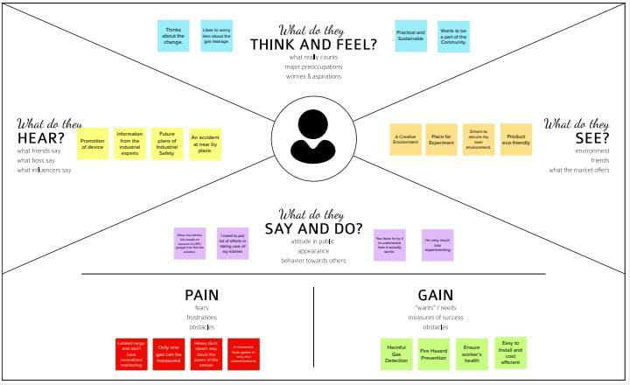

3.2 IDEATION AND BRAINSTORMING:

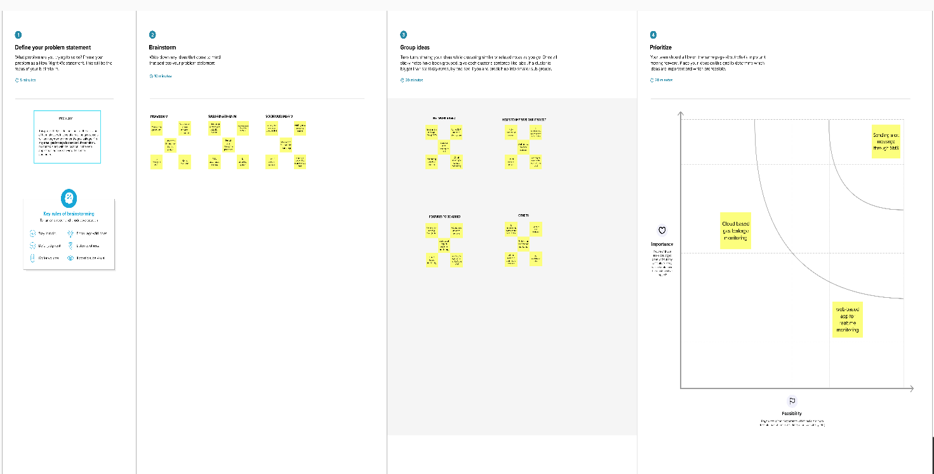

3.3 PROPOSED SOLUTION:

|  |  |  |
| --- | --- | --- |
| **S.No.** | **Parameter** | **Description** |
| 1. | Problem Statement (Problem to be solved) | Workers who are engaged with busy industries packed with gas either harmful or harmless needs a way to monitor their gas pipelines continuously and detect early if there is any leakage of gas in their surroundings so that they can work eﬃciently on major crises rather than worrying about monitoring or leakage of gas, this will indeed reduce the manpower of that industry and create a peaceful environment. |
| 2. | Idea / Solution description | Workers who are engaged with busy industries packed with gas either harmful or harmless needs a way to monitor their gas pipelines continuously and detect early if there is any leakage of gas in their surroundings so that they can work eﬃciently on major crises rather than worrying about monitoring or leakage of gas, this will indeed reduce the manpower of that industry and create a peaceful environment. |
| 3. | Novelty / Uniqueness | Even though there are many existing solutions for this problem they failed to satisfy the needs of customer. Some of the solutions are only detecting some particular gases where some others failed to alert the main department and other solutions are with some delays. Our solution not only notify the industry person but also notify the ﬁre ﬁghters so that can take control over the situation and our solution will alert the workers even there is a smallleak of gases. |
| 4. | Social Impact / Customer Satisfaction | Our solution will be very helpful for the workers and the society which is associated or located nearby the industries. Our solution will prevent great disasters like Bhopal Gas Tragedy so that so many lives can be saved. Through this project the workers mental pressure will be reduced so that they can concentrate on other works or by relaxing them. |
| 5. | Business Model (Revenue Model) | The main target of our solution is Industries so we have planned to visit industries and explain them about the beneﬁts of our products. So that they can aware of the importance of this solution and use it. |
| 6. | Scalability of the Solution | Our solution can be integrated for further future use because the solution we have provided will be lay onthe basic or initial stage of any upgraded version. |

3.4 PROPOSED SOLUTION FIT:

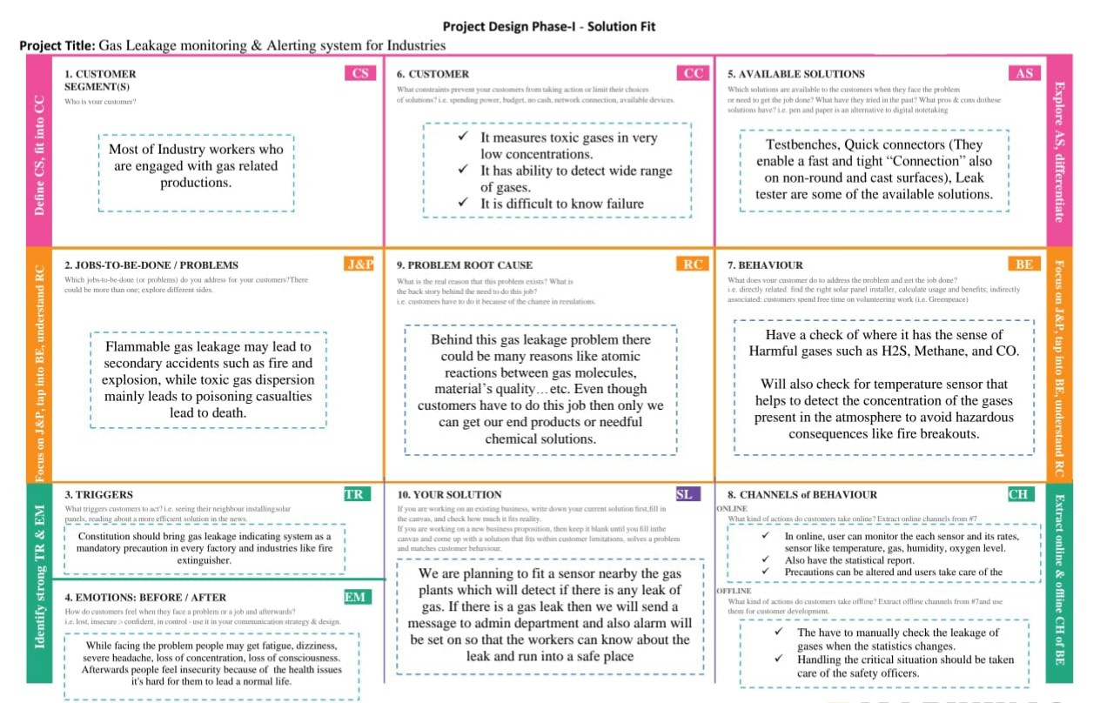

4. REQUIREMENT ANALYSIS

4.1 FUNCTIONAL REQUIREMENT:

|  |  |  |
| --- | --- | --- |
| **Business Requirements** | **User Requirements** | **Product Requirements** |
| The mentioned system is usable in residences, hotels, industrial settings, LPG cylinder storage places, etc. The ability to detect leakage and transmit the information to a location is the primary benefit of this IoT and Arduino-based application. It is observable, and precautions can be taken to avert any catastrophe. | The gas leakage detection system can be upgraded with smoke and fire detectors to detect the presence of smoke and fire in addition as being optimised for detecting dangerous gases. Although ensuring worker safety is critical, adopting the appropriate technology is even more crucial. | Regardless of your professional position or personal goals, gas detection is essential. Such IoT devices are what they are due to certain technologies in use, therefore understanding these technologies and the functions they can serve is necessary if you want to engage in IoT application development. |

4.2 NON FUNCTIONAL REQUIREMENT:

* Data Gathering:

Using multiple sensors, we are going to gather the necessary data.

* Data Store:

Collected data is stored in Cloud and Necessary databases.

* Data Analysis:

Data from the store must be analyzed for raising alerts in case of necessity.

* Data Monitoring:

Gathered data must be displayed to the user for monitoring.

5. PROJECT DESIGN:

5.1 DATA FLOW DIAGRAM:

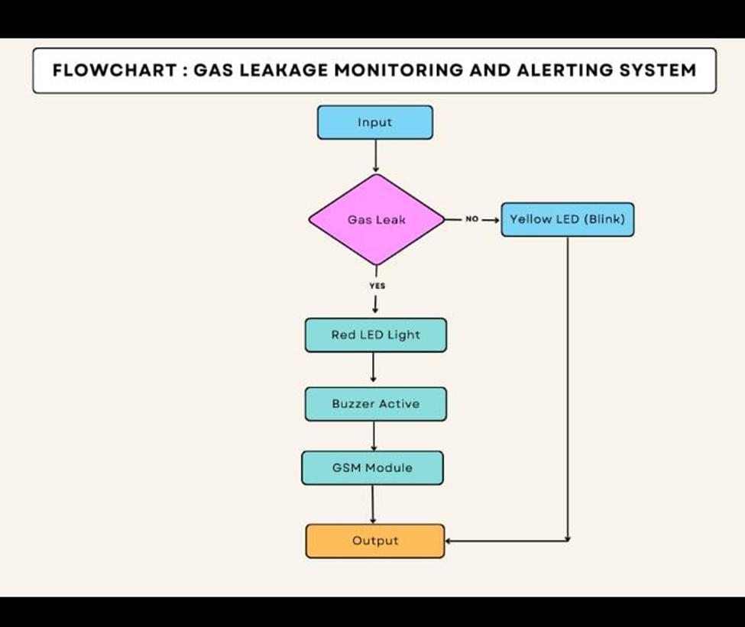

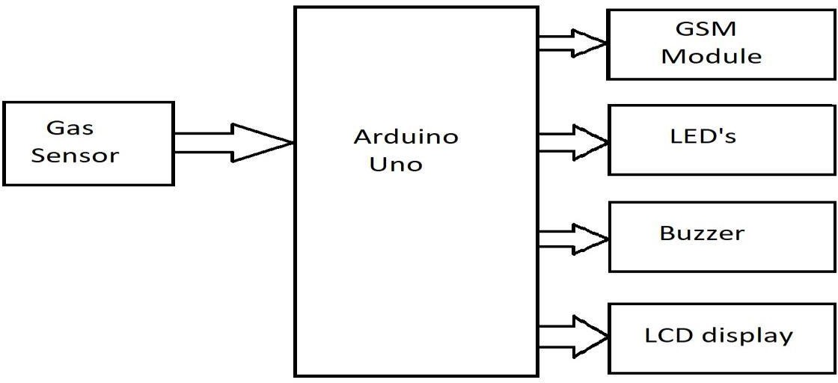

5.2 SOLUTION AND TECHNICAL ARCHITECTURE:

The system can be taken as a small attempt in connecting the existing primary gas detection methods to a mobile platform integrated with IoT platforms. The gases are sensed in an area of 1m radius of the rover and the sensor output datas are continuously transferred to the local server. The accuracy of MQ sensors are not upto the mark thus stray gases are also detected which creates an amount of error in the outputs of the sensors, especially in case of methane. Further the availability and storage of toxic gases like hydrogen sulphide also creates problems for testing the assembled hardware. As the system operates outside the pipeline, the complication of system maintenance and material selection of the system in case of corrosive gases is reduced. Thus the system at this stage can only be used as a primary indicator of leakage inside a plant.

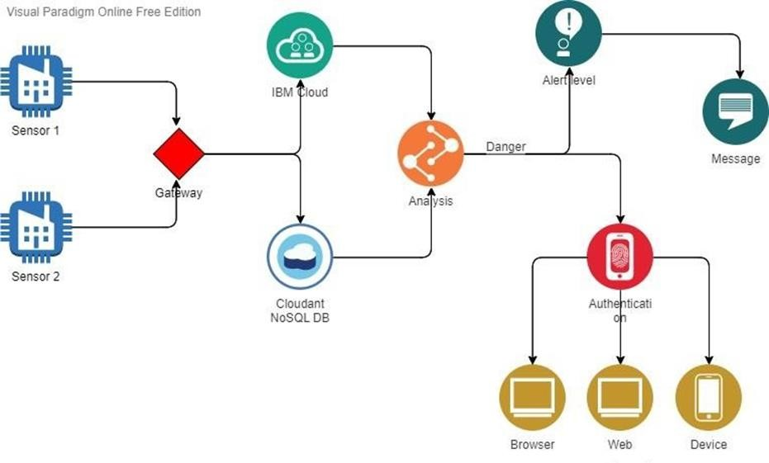

5.3 USER STORIES:

The system can be taken as a small attempt in connecting the existing primary gas detection methods to a mobile platform integrated with IoT platforms. The gases are sensed in an area of a 1m radius of the rover and the sensor output data are continuously transferred to the local server. The accuracy of sensors is not up to the mark thus stray gases are also detected which creates an amount of error in the outputs of the sensors, especially in the case of methane. Further, the availability and storage of toxic gases like hydrogen sulfide also create problems for testing the assembled hardware. As the system operates outside the pipeline, the complication of system maintenance and material selection of the system in case of corrosive gases is reduced. Thus, the system at this stage can only be used as a primary indicator of leakage inside a plant.

6. PROJECT PLANNING & SCHEDULING

6.1 SPRINT PLANNING AND ESTIMATION



6.2 SPRINT DELIVERY SCHEDULE: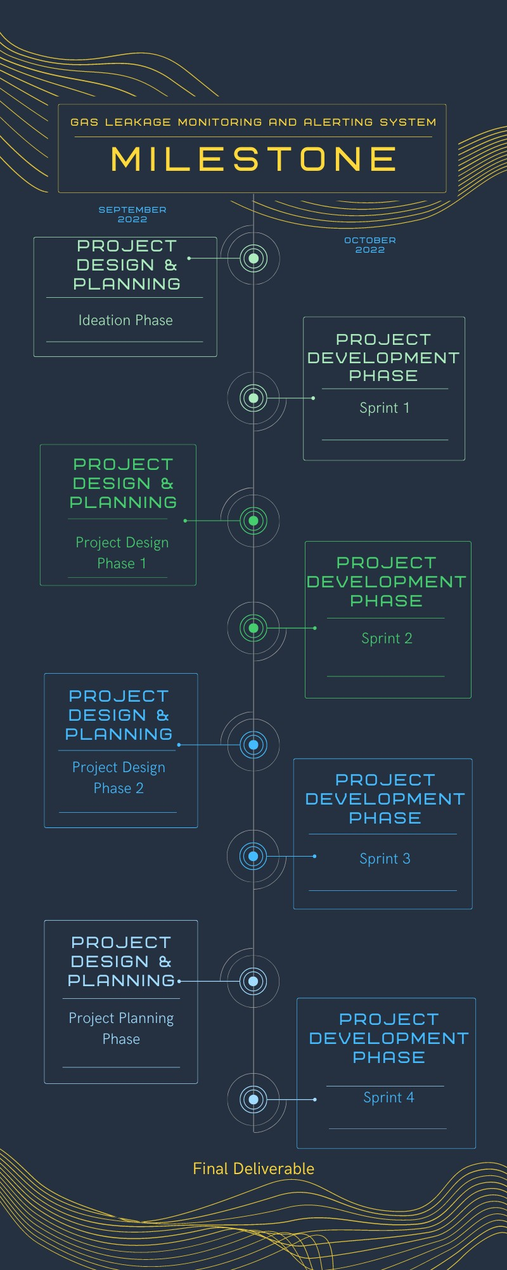

7.CODING AND SOLUTIONING:

//Code for Blinking LED//

import RPi.GPIO as GPIO

import time

LED = 40

GPIO.setwarnings(False)

GPIO.setmode(GPIO.BOARD)

GPIO.setup(LED, GPIO.OUT)

while True:

GPIO.output(LED,GPIO.HIGH)

time.sleep(1)

GPIO.output(LED,GPIO.LOW)

time.sleep(1)

//Code for Traffic Light System//

from gpiozero import Button, TrafficLights, Buzzer

from time import sleep

buzzer = Buzzer(15)

button = Button(21)

lights = TrafficLights(25, 8, 7)

while True:

button.wait_for_press()

buzzer.on()

light.green.on()

sleep(1)

lights.amber.on()

sleep(1)

lights.red.on()

sleep(1)

lights.off()

buzzer.off()

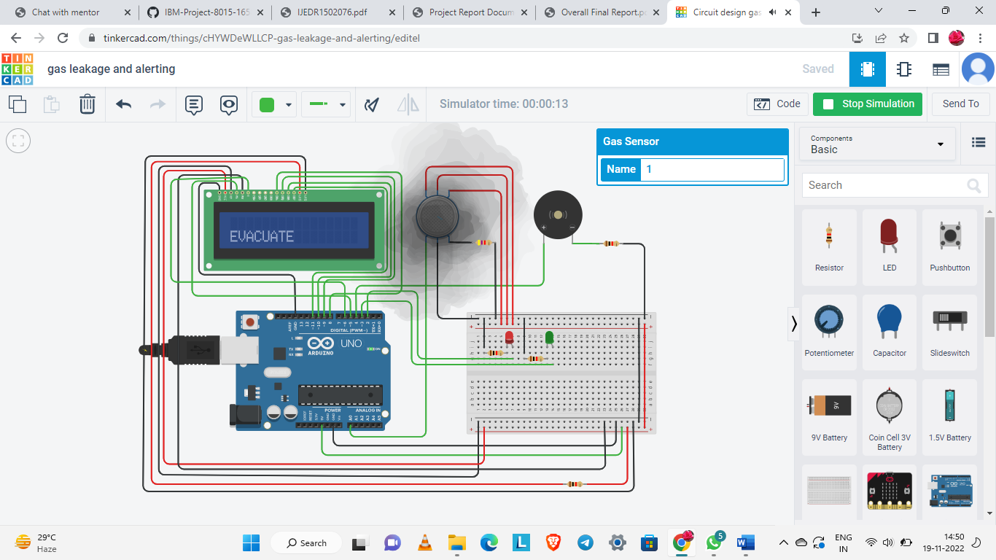

8.TESTING:

TINKERCAD

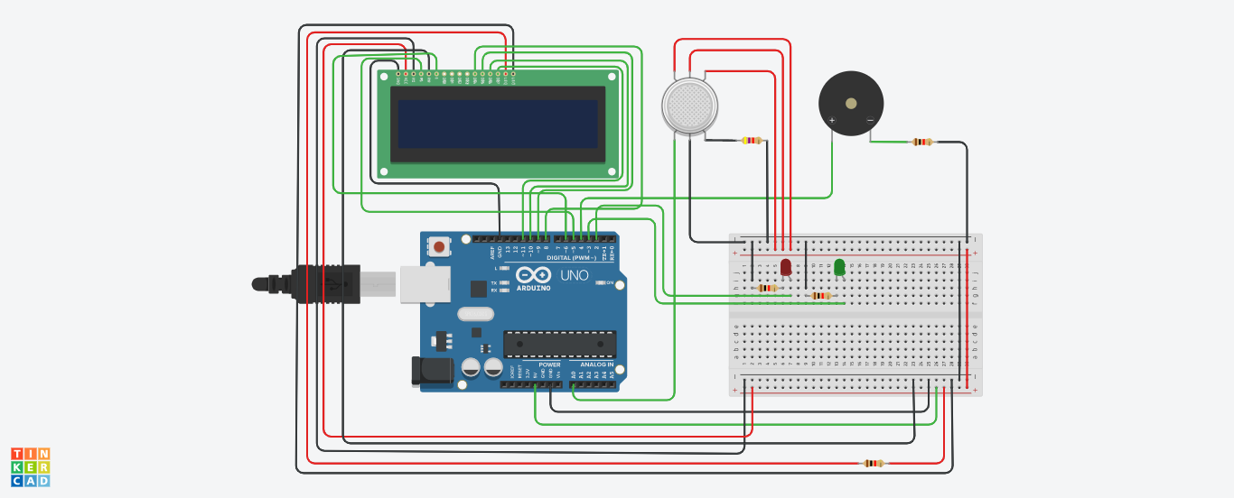

PYTHON CODE EXECUTION:

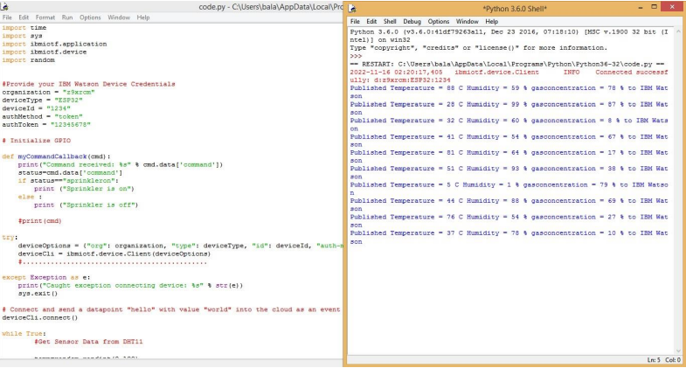

COMPONENTS:

The design of a sensor-based automatic gas leakage detector with an alert and control system. The components are

|  |  |  |
| --- | --- | --- |
| **S. No.** | **Name of the Component** | **Quantity** |
| 1. | Arduino UNO R3 | 1 |
| 2. | Breadboard | 1 |
| 3. | LED | 2 |
| 4. | Resistor | 5 |
| 5. | Piezo | 1 |
| 6. | Gas Sensor | 1 |
| 7. | LCD (16x2) | 1 |

9. RESULT:

9.1 RESULTANT METRICES:



SOLUTION STATEMNET:

The system might be viewed as a modest attempt to link up the principal gas detection techniques now in use with a mobile platform coupled with IoT platforms. One metre around the rover, the gases are detected, and the sensor output data is continually sent to the nearby server. Stray gases are also detected because of the sensors' subpar precision, which introduces some inaccuracy into their results, particularly in the case of methane. Additionally, the storage and availability of hazardous gases like hydrogen sulphide makes it difficult to test the integrated gear. The complexity of system maintenance and material selection for the system in the event of corrosive gases is reduced because the system operates outside the pipeline. The system can only be used as a primary indicator of leakage inside a plant at this point.

10. ADVANTAGES:

* Get real-time alerts about the gaseous presence in the atmosphere
* Prevent fire hazards and explosions
* Supervise gas concentration levels
* Ensure worker’s health.
* Real-time updates about leakages
* Cost-effective installation
* Get immediate gas leak alert.
* Fully Automated System.
* If proper steps are taken instantly, it can save loss of life and property.
* It can also be used to detect other poisonous gases.

DISADVANTAGES:

* User needs to check the LED lights for leakage.
* Installation cost can be high

11. CONCLUSION:

We can conclude from the project's performance that the system's detection of LPG gas leakage is remarkable. Useful for both residential and commercial purposes. We can use this technique to save lives in dangerous situations. The GSM module indicates an alert. Propane, CO2, and other gases are detected by a sensor node. Power usage and transmission range estimates are made. The sensor was constructed using straightforward techniques and an Arduino UNO Micro controller.

12. FUTURE SCOPE:

The project's future goals include expanding the system's software-based intelligent capabilities. This system automatically detects, regulates, and alerts to gas emissions. When an accident occurs, this system will soon contain a feature that will alert the emergency services. There will also be included a web-based and mobile app for real-time monitoring. This system's user app will get a lot of smart features added. The system will be safer for consumers because to its overall features. The system will be prepared for usage in a variety of settings, including the home, workplaces, and automobiles. The technology will be put into practise in a real-world setting after the final prototype is designed with clever multipurpose features.

1. APPENDIX:

SOURCE CODE:

#include <LiquidCrystal.h>

LiquidCrystal lcd(5,6,8,9,10,11);

int redled = 2;

int greenled = 3;

int buzzer = 4;

int sensor = A0;

int sensorThresh = 400;

void setup()

{

pinMode(redled, OUTPUT);

pinMode(greenled,OUTPUT);

pinMode(buzzer,OUTPUT);

pinMode(sensor,INPUT);

Serial.begin(9600);

lcd.begin(16,2);

}

void loop()

{

int analogValue = analogRead(sensor);

Serial.print(analogValue);

if(analogValue>sensorThresh)

{

digitalWrite(redled,HIGH);

digitalWrite(greenled,LOW);

tone(buzzer,1000,10000);

lcd.clear();

lcd.setCursor(0,1);

lcd.print("ALERT");

delay(1000);

lcd.clear();

lcd.setCursor(0,1);

lcd.print("EVACUATE");

delay(1000);

}

else

{

digitalWrite(greenled,HIGH);

digitalWrite(redled,LOW);

noTone(buzzer);

lcd.clear();

lcd.setCursor(0,0);

lcd.print("SAFE");

delay(1000);

lcd.clear();

lcd.setCursor(0,1);

lcd.print("ALL CLEAR");

delay(1000);

}

}

PYTHON CODE:

//Code for Blinking LED//

import RPi.GPIO as GPIO

import time

LED = 40

GPIO.setwarnings(False)

GPIO.setmode(GPIO.BOARD)

GPIO.setup(LED, GPIO.OUT)

while True:

GPIO.output(LED,GPIO.HIGH)

time.sleep(1)

GPIO.output(LED,GPIO.LOW)

time.sleep(1)

//Code for Traffic Light System//

from gpiozero import Button, TrafficLights, Buzzer

from time import sleep

buzzer = Buzzer(15)

button = Button(21)

lights = TrafficLights(25, 8, 7)

while True:

button.wait_for_press()

buzzer.on()

light.green.on()

sleep(1)

lights.amber.on()

sleep(1)

lights.red.on()

sleep(1)

lights.off()

buzzer.off()

GITHUB LINK:

[**https://github.com/IBM-EPBL/IBM-Project-45212-1660728855.git**](https://github.com/IBM-EPBL/IBM-Project-45212-1660728855.git)

DEMO LINK:

<https://youtu.be/0ruMor364u4>